Mulesoft Anypoint Platform
Experiment 7
Create a Mule project to insert and retrieve records from the MySQL table student1 using the Database module.
Solution:
In this experiment, you will build two flows:
- One to insert student records into the database.
- Another to retrieve and display those records as JSON.
Steps:
- Continue in the same project which was created in the experiment 6.
- Drag an HTTP Listener to the canvas for inserting data.
  - Path: /insert
  - Use the same configuration as the previous flow.
- Drag a Database - Insert component after the transform.
- 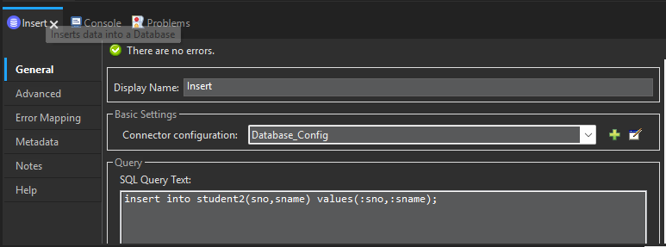
  - Use the same global DB config from Experiment 6.
  - SQL Query:
    - insert into student2(sno,sname) values(:sno,:sname);
  - Add the input parameters.
- 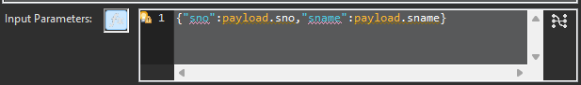
- Add a Transform Message component after the Listener:
  - Add the message “inserted data successfully

- The final flow will look like this:
- 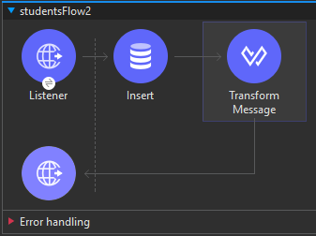
- Next add another HTTP Listener for retrieval.
  - Path: /getstudents
  - Config same as the previous flow.
- Drag a Database - Select component after the listener.
  - SQL Query:
    - SELECT * FROM student2;
    - 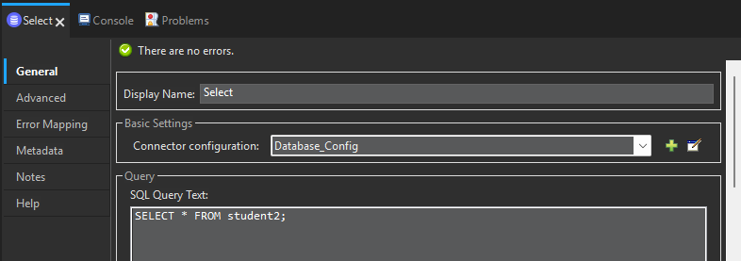
- Add a Transform Message component to format the response as JSON.
- The final will look like this
- 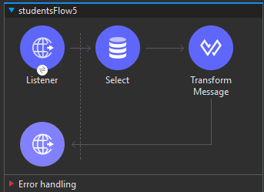

- Next save the project and run it.

- Open Postman and try to insert the data you should get output like this:

- 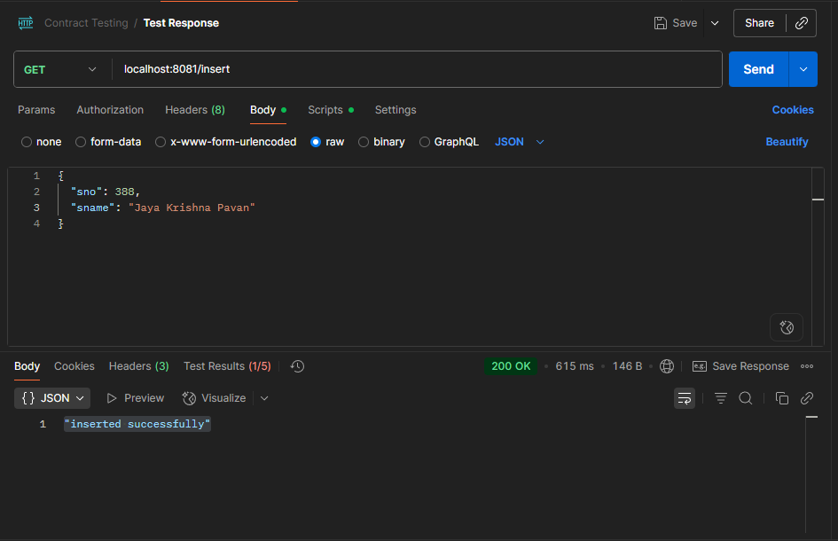

- Do the same with select:

- 